Ai assisted coding Assignment-9.4
Name:Kanneboyina Meghana
Batch-44
HTNO:2303a52345
Task1:
Prompt: Generate Google-style docstrings including description, parameters with types, return type, and example usage.
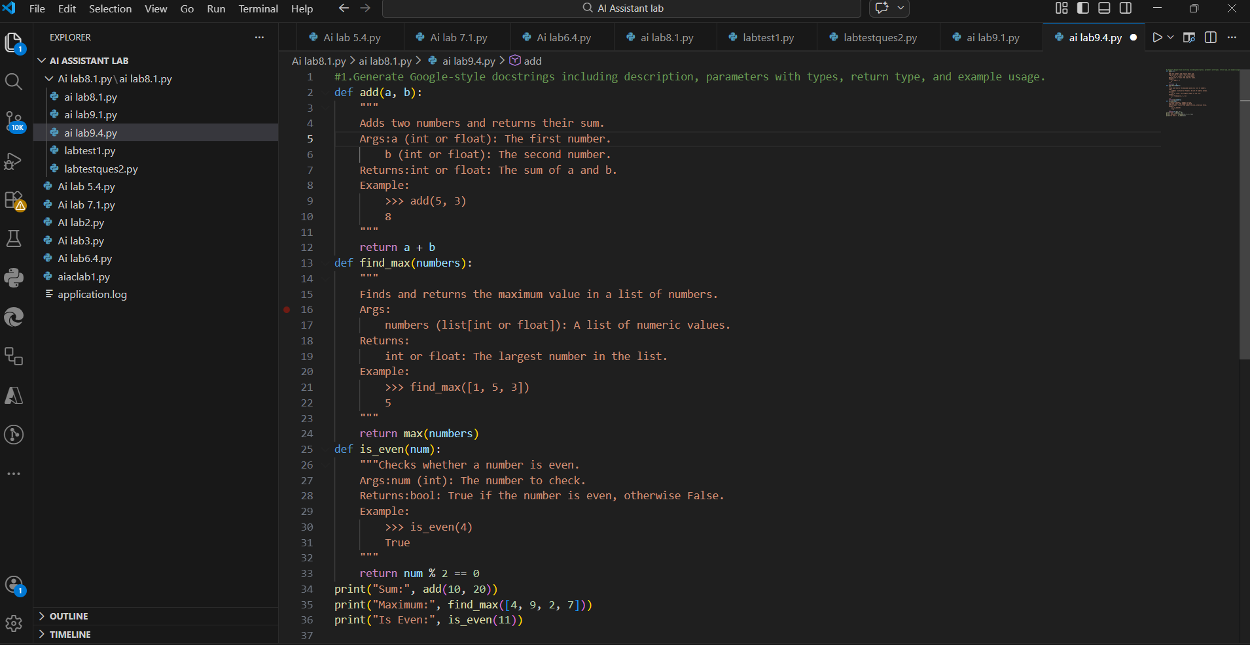
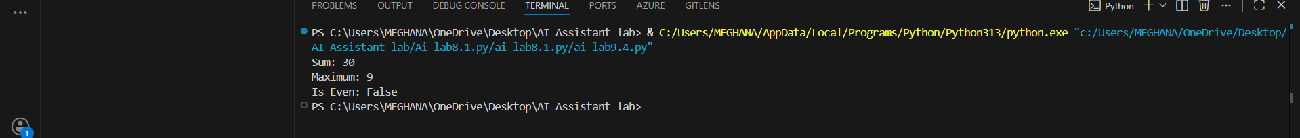
Observation:
1.AI successfully generated structured Google-style docstrings for all functions.
2. Each docstring clearly includes description, parameters with data types, return values, and example usage.
3. The documentation improves code readability and helps new developers understand function behavior quickly.
4.The functions become easier to reuse in larger projects due to clear usage examples.
5. Using a context-based prompt produces more detailed and professional documentation compared to a simple zero-shot prompt.
Task2: Enhancing Readability Through AI-Generated Inline Comments
Prompt: Insert inline comments explaining only complex or non-obvious logic in the given Python program without commenting on trivial syntax.
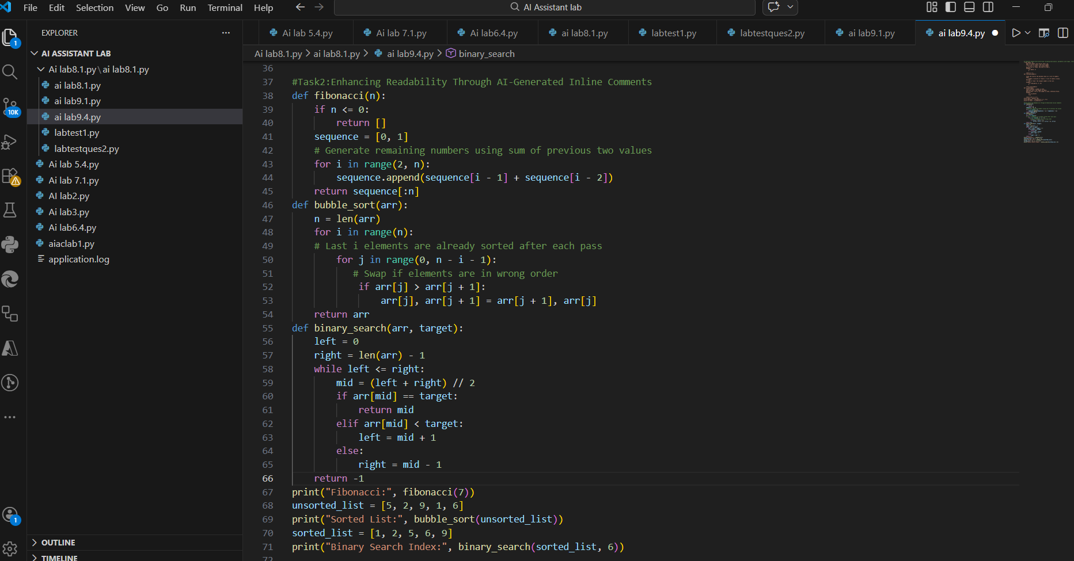
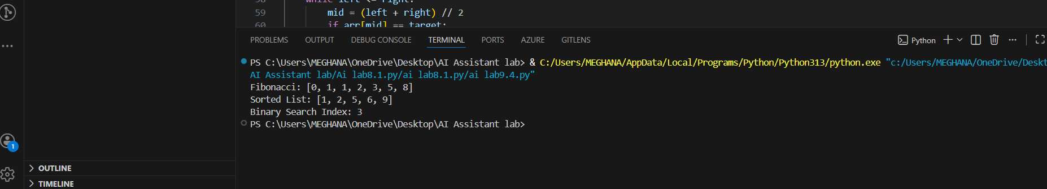
Observation:
1.AI added comments only for algorithm reasoning and complex logic.
2.Trivial statements like variable declarations were not commented.
3.Comments clearly explain why swapping or search boundary updates occur.
4.Code readability improved without unnecessary clutter.
5. Future developers can easily understand and maintain the program.
Task 3: Generating Module-Level Documentation for a Python Package
Prompt: Generate a professional module-level docstring describing the module purpose, dependencies, key functions/classes, and usage example.
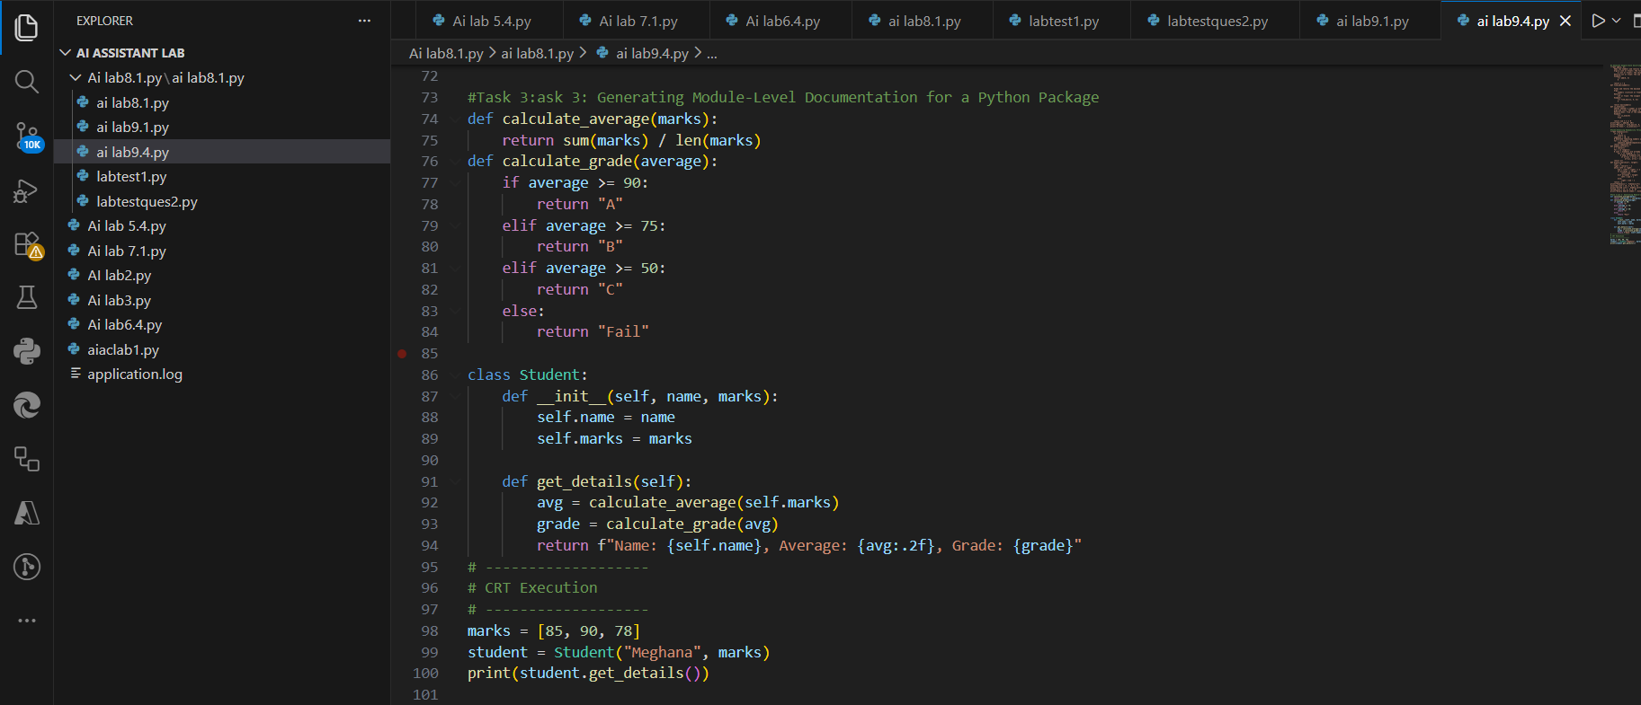
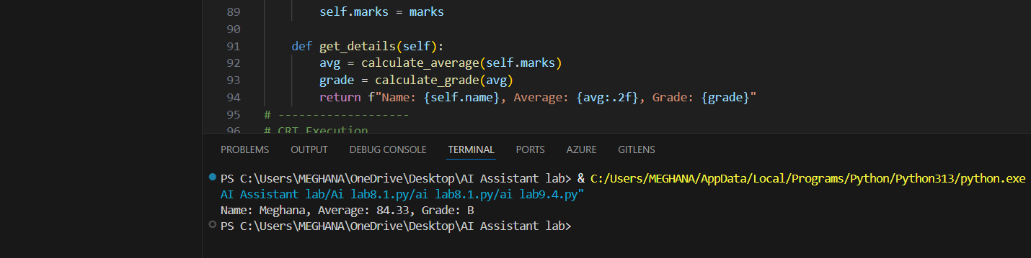Observation:
1.The AI generated a clear and professional multi-line module-level docstring.
2.The purpose of the module is clearly explained at the beginning.
3.Dependencies and key components are properly listed.
4. Example usage helps developers quickly understand how to use the module.
5. The documentation is suitable for real-world repository or internal sharing.
Task 4: Converting Developer Comments into Structured Docstrings
Prompt: Convert the inline developer comments into structured Google-style docstrings while preserving meaning and removing redundant comments.
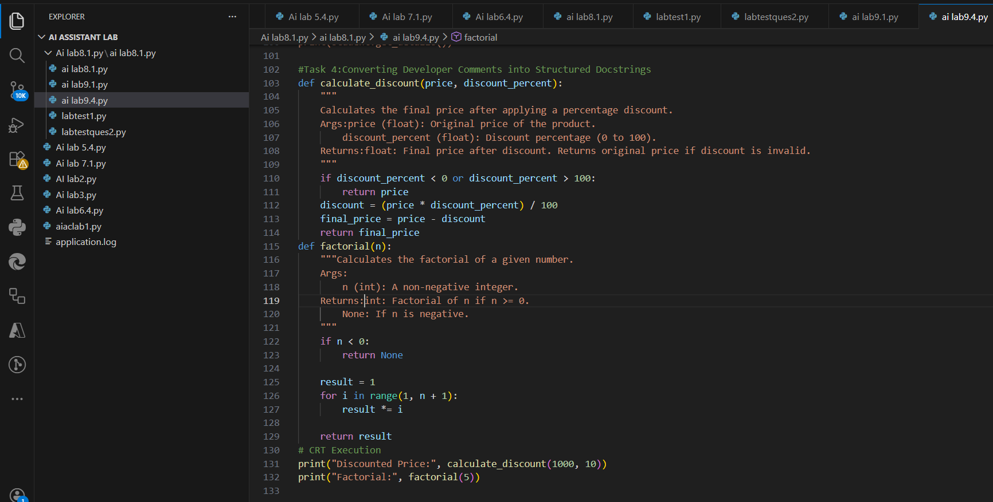
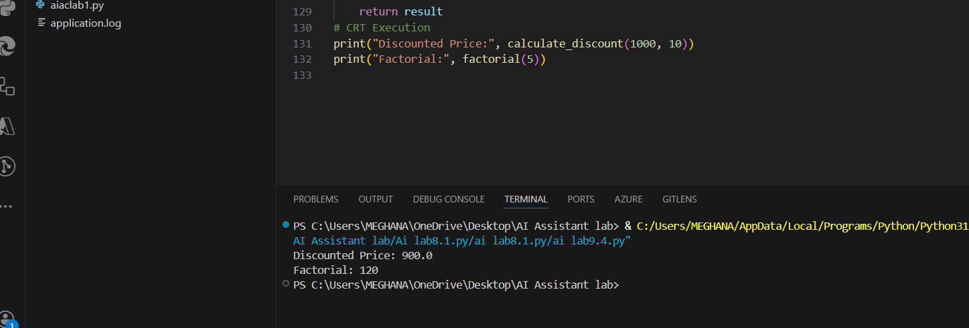
Observation:
1.AI successfully converted long inline comments into structured Google-style docstrings.
2. Original meaning and logic were preserved accurately.
3. Redundant inline comments were removed, reducing code clutter.
4. Documentation is now standardized and professional.
5.Codebase consistency and maintainability are improved.
Task 5: Building a Mini Automatic Documentation Generator
Prompt: Create a Python utility that reads a .py file, detects functions and classes, and inserts placeholder Google-style docstrings automatically.
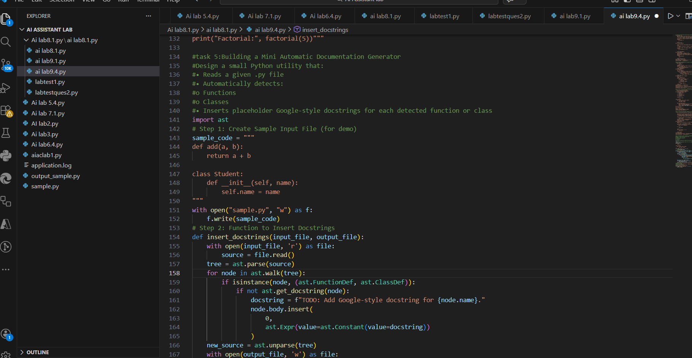
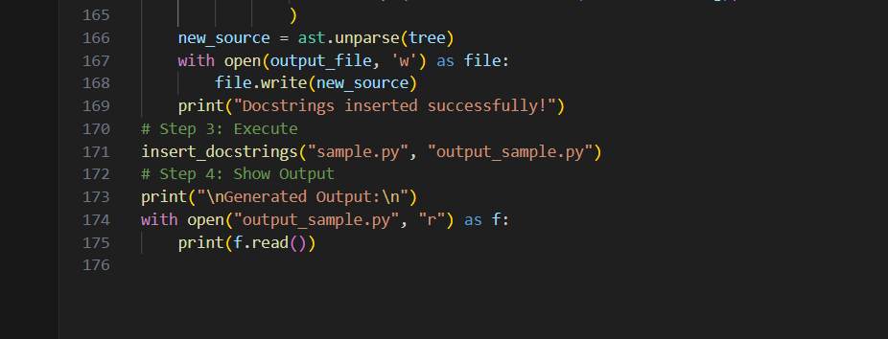
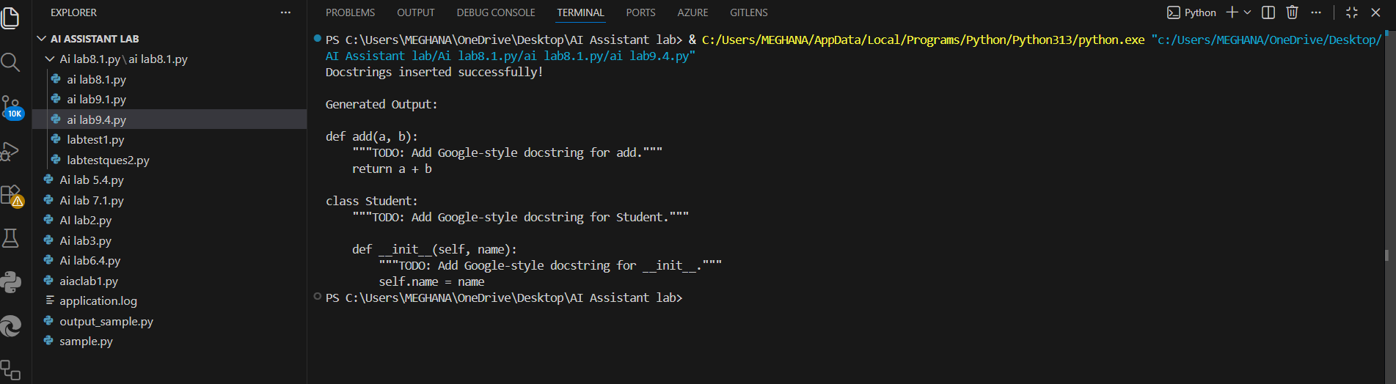
Observation:
1.The program reads a given .py file successfully.
2. It detects functions and classes using the ast module.
3. Placeholder Google-style docstrings are automatically inserted.
4.Existing docstrings are not affected (if checked in code).
5. A new output file is generated with added documentation.
6.The tool helps in automatic documentation scaffolding.

